<https://lighthouseguild.org/assistive-navigation-technologies/>

-

Blog

**Assistive Navigation Technologies**

Safely navigating a new environment, both indoors and outdoors, can be a challenge for people who are blind or visually impaired. Orientation and mobility training is necessary to ensure independent and safe travel, as is the importance of using a white cane or a guide dog. While not meant to replace them, some technologies can help with navigation and are available at Lighthouse Guild.

**NaviLens**

Traditional building and transit signage can be difficult for people with a vision impairment to access. Using a smartphone’s camera, [NaviLens](https://www.navilens.com/en/) has created a code – much like a QR code – that can be detected instantly, without the need to focus, from over 50 feet away (depending on size) and at extreme angles.

The NaviLens code is shaped like a square, with a black border surrounding a grid of smaller colored squares. Through the use of the NaviLens free app (iOS and Android), a smartphone’s camera detects the code and immediately gives the user information on the environment, points of interest, distance to the code, and guidance to it. The information can be provided in many different languages.

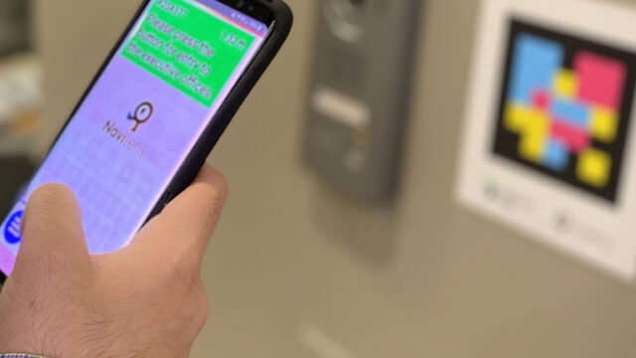

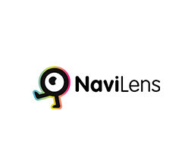

**Download the NaviLens App for Free!**

Photo to the left: a smartphone’s camera detects the NaviLens code and immediately gives the user information on the environment, points of interest, distance to the code, and guidance to it via the NaviLens app.

[NaviLens App (Apple)](https://apps.apple.com/us/app/navilens-go/id1313878412)

[NaviLens App (Google Play)](https://play.google.com/store/apps/details?id=com.neosistec.NaviLens&hl=en_US&gl=US)

NaviLens codes are used by the transit system in Barcelona, Spain – Giving visually impaired transit riders information on location and real-time information on train and bus arrivals. NaviLens is being piloted in New York City at the 23rd Street Bus line, Jay Street MetroTech subway station and on some floors of Lighthouse Guild.

NaviLens is even being used on packaging, providing information on the product, such as nutritional facts as well as guidance to the product itself. Check out how Kellogg’s is using [NaviLens codes](https://youtu.be/oLkCvzqd5b4) on their products.

**RightHear**

What if signs could talk? [RightHear](https://www.right-hear.com/) is doing just that through an audible wayfinding system. The RightHear system comprises an accessible app (iOS and Android), a web portal to enter information, and a Bluetooth beacon. While using the app, a strategically placed beacon transmits a pre-programmed message which is picked up and made available by a smartphone. Lighthouse Guild is currently testing the technology throughout its building.

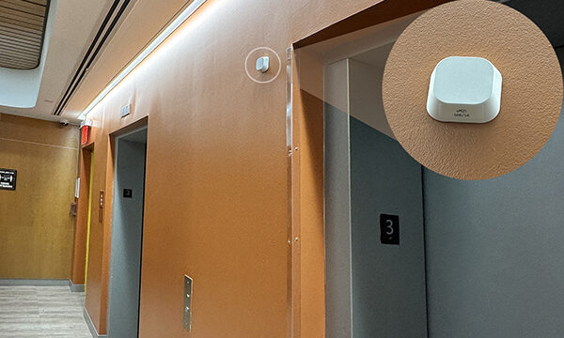

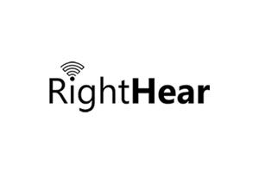

**Download the RighHear App for Free!**

Photo to the left: a beacon strategically placed at a top corner of an elevator entrance transmits a pre-programmed message which is picked up by an accessible app on a smartphone.

[RightHear Blind Assistant App (Apple)](https://apps.apple.com/us/app/righthear/id1061791840)

[RightHear Blind Assistant App (Google Play)](https://play.google.com/store/apps/details?id=com.righthear&hl=en_US&gl=US)

Information sent can include important notices or descriptive information to give someone a better orientation of their surroundings. Examples of information may include business hours, info from an office floor directory, building emergency information, approximate location of restrooms, emergency exits, or other useful items.

The RightHear system has been implemented in over 2,000 locations and is in all the McDonald’s and Pizza Hut restaurants in Israel. Not only can RightHear be used for indoors but also outdoor orientation utilizing GPS for wayfinding and calling out points of interest, providing the direction by clock hour and distance in feet or meters.

**GoodMaps**

Similar to the technology being used in autonomous vehicles, [GoodMaps](https://goodmaps.com/) uses image recognition and Light Detection And Ranging (LiDAR) technology to provide people with vision loss a digital map of indoor environments. Navigation is accessed through the GoodMap app on a smartphone (iOS and Android).

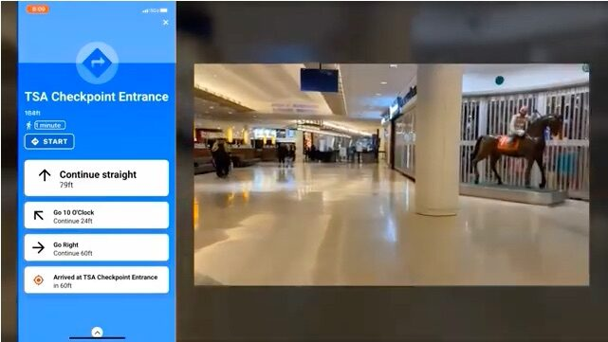

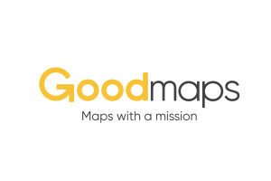

**Download the GoodMaps App for Free!**

Photo to the left: the interface of the GoodMap app on a smartphone.

[GoodMaps Explore App (Apple)](https://apps.apple.com/us/app/goodmaps-explore/id1524698552)

[GoodMaps Explore App (Google Play)](https://play.google.com/store/apps/details?id=com.goodmaps.explore&hl=en_US&gl=US)

[GoodMaps OutDoors App (Apple)](https://apps.apple.com/us/app/goodmaps-outdoors/id945756779)

[GoodMaps Outdoors App (Google Play)](https://play.google.com/store/apps/details?id=com.goodmaps.outdoors&hl=en_US&gl=US)

To take advantage of GoodMaps, first a building must be scanned using LiDAR technology. Scanning time depends on the size of a facility/building after which a map is developed and shared on their app. LiDAR offers a digital map without the need for signage or a physical device on a wall. The GoodMaps company also promotes that this technology can be helpful to first responders in cases of emergencies. Three floors at Lighthouse Guild were scanned and testing will begin soon.

The GoodMaps app also offers the ability to do outdoor wayfinding, create a user’s routes and get points of interest and intersections to help with finding destinations.

**What’s Next in Navigation Technology?**

Check out Lighthouse Guilds podcast [On Tech and Vision,](https://lighthouseguild.org/technology/on-tech-and-vision-podcast/) where Dr. Cal Roberts speaks to the visionaries with big ideas on the future of technology for people with vision loss. Join Dr. Roberts when he talks with [Javier Pita](https://lighthouseguild.org/how-the-simple-qr-code-became-an-empowering-navigation-tool/) from NaviLens, [Mike May](https://lighthouseguild.org/new-approaches-in-access-smart-tools-for-indoor-navigation-and-information-transfer/) from GoodMaps and [Idan Meir](https://lighthouseguild.org/new-approaches-in-access-smart-tools-for-indoor-navigation-and-information-transfer/) from RightHear, as they discuss the future of navigation.

Don’t miss **Tech Talk Tuesday**, every third Tuesday of the month with Lighthouse Guild’s Chief Technology Officer, Dr. Bryan Wolynski as he discusses a wide variety of topics on today’s assistive technology and its uses. [Register for Tech Talk today!](https://lighthouseguild.org/register-for-tech-talk/)